LAB 7

1.minimum and maximum

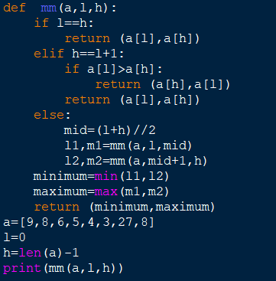

OUTPUT:

2.binary search

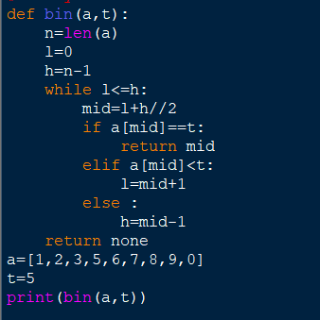

OUTPUT:

1. Merge sort

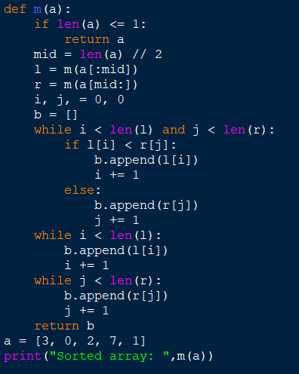

OUTPUT:

1. Quick Sort

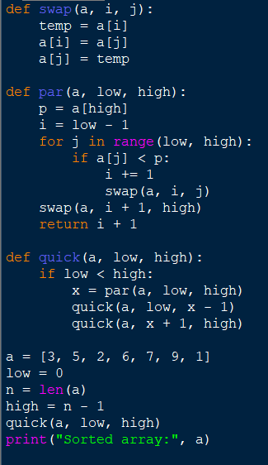

OUTPUT:

1. Stassens algorithm

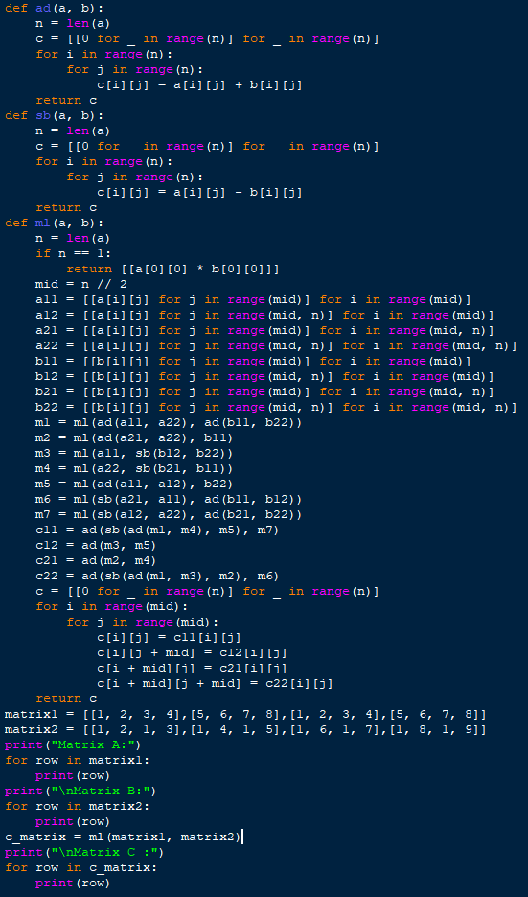

OUTPUT:

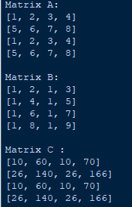

1. Karatsuba Algorithm for Multiplication of Integers

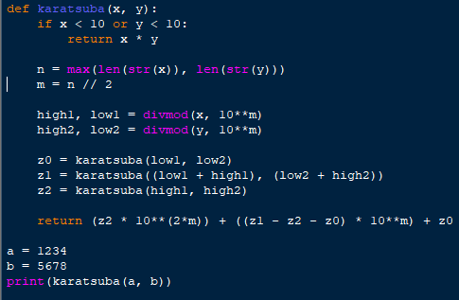

OUTPUT:

1. Closest Pair

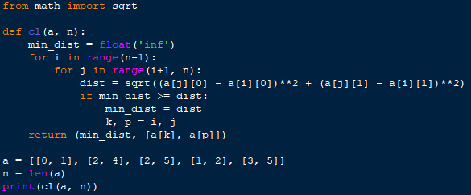

OUTPUT:

1. Median of Medians

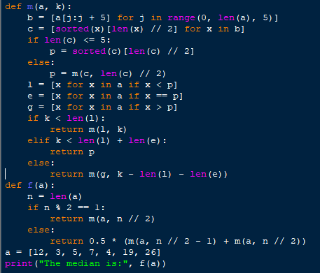

OUTPUT:

1. Meet in the Middle

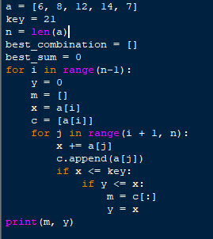

OUTPUT: